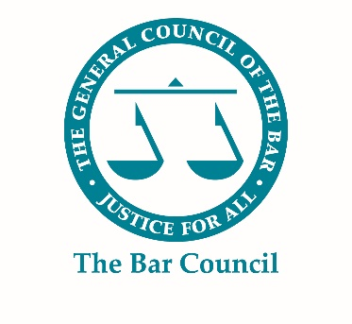

Silk & Judicial mentor application form

Please complete all questions on this application form.
Please note: the information provided may be published on the Bar Council website to assist mentees during the application process. Confidential information (marked in red) will not be published online, or shared with mentees once matched.
Full Name:
Chambers/ Employer:
Primary Court:
Circuit:
Area(s) of Practice/ Specialism:
Membership(s):
Year of Call:
Year of Silk:
Year of Judicial Appointment:
Which competition application are you willing to provide assistance with? (please tick)
Silk |  | ☐ |  | Judicial | ☐ |  |  | Both |  | ☐
What is your preferred method of communication? (please tick)
Email | ☐ |  | Telephone |  | ☐ |  |  | Face to Face |  | ☐
Biography
Please provide a brief biography (no more than 250 words) which includes the following:
- A summary of your career including career highlights;
- Previous mentoring experience and/ or training;
- Background and experience which you consider might be useful for a potential mentee (e.g. if you have taken a career break, overcome discrimination at the Bar for any particular reason, or managed an illness whilst at the Bar);
- Any other information which you consider relevant

Confidential Information
Contact telephone number:
Contact email address:
Please indicate the number of mentoring relationships you are prepared to undertake at any one time: |  |  |  |  |  | 1 | ☐
 |  |  |  |  |  | 2 | ☐
Have you participated in a mentoring programme before? |  |  |  |  |  |  | Yes ☐ |  | No ☐
If yes, |  |  |  |  |  |  | Mentor ☐ |  | Mentee ☐
(Please provide further details)
I declare that the information on this form is accurate and true, and that any false or misleading information may lead to the offer of a mentoring role being withdrawn. |  |  |  |  |  |  | ☐
Please tick to confirm you have read and agreed to the Terms and Conditions of the Bar Mentoring Scheme |  |  |  |  |  |  | ☐

Please email your completed form to: Mentoring@BarCouncil.org.uk

Please note: although electronic copies are preferred (and can be downloaded from the Bar Council website) if you prefer to fill this form in in hard copy, please do so and post it to the Bar Council marking it to the attention of:

Bar Mentoring Service (Silk and Judicial Appointments Scheme)
The Bar Council
289-293 High Holborn
London
WC1V 7HZ

