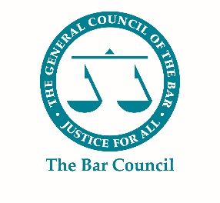
Pupillage Fair 2021
FAQs

Question | Page Number
What is the Bar Council Pupillage Fair? | 2
Why should we attend the Pupillage Fair? | 2
What will the virtual Pupillage Fair include? | 3
What upgrades have been made to the platform? | 5
How much does it cost to exhibit at the Pupillage Fair? | 6
We would like to exhibit but we cannot afford to. Does the Bar Council offer any discounts? | 7
Will the Pupillage Fair remain virtual from now on? | 8
I have got a question. Who can I contact? | 8

- What is the Bar Council Pupillage Fair?

The Bar Council Pupillage Fair, which is held with the support of the Council of the Inns of Court and the Chancery, Commercial, Criminal, Employment Law, Family and Technology and Construction Bar Associations is the only recruitment fair run by the Bar, for the Bar of the future. Over the past six years it has grown significantly in size and become a key fixture in the profession’s calendar. The Fair forms an important part of the Bar Council’s strategic commitment to fair access and to a meritocratic culture, regardless of background. It also provides Authorised Education and Training Organisations (“AETOs”) and other relevant organisations with an opportunity to invest in the future of the profession and improve access to the Bar.
Figure 1: Lobby – Pupillage Fair 2020
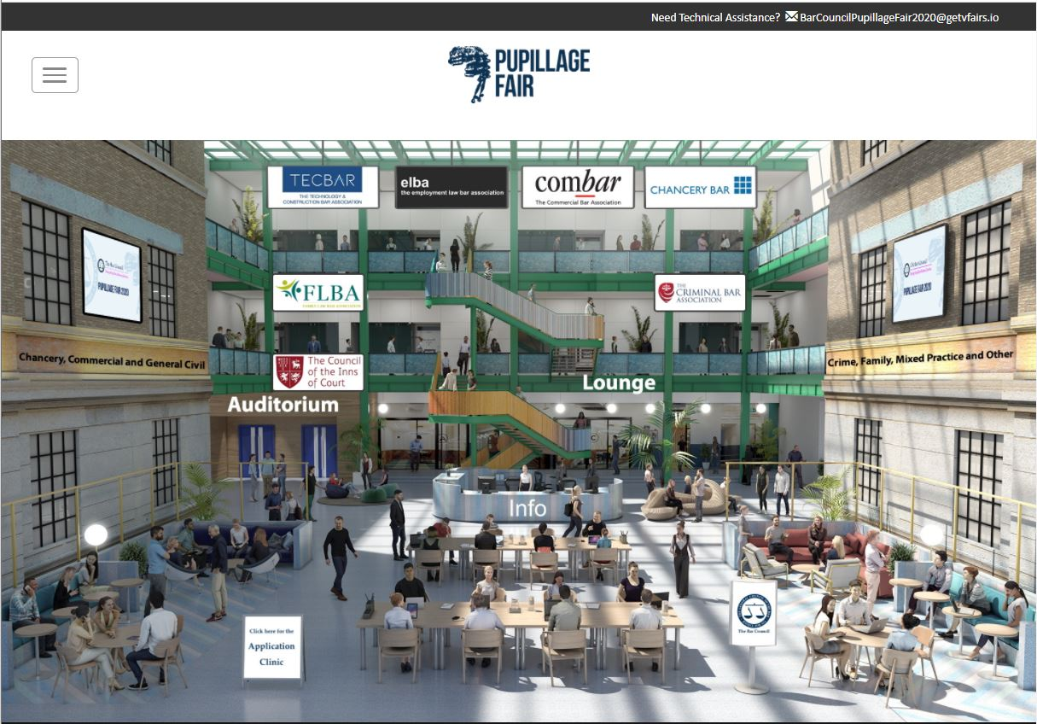

- Why should we attend the Pupillage Fair?

The Bar Council feels that it is important to demonstrate to aspiring barristers that there are still plenty of opportunities to join the profession and that they will be able to build a successful career at the Bar in the post-coronavirus era. The Bar Council Pupillage Fair offers aspiring barristers the perfect opportunity to improve their understanding of the profession and the various organisations associated with it, by allowing them to meet and ask questions of AETOs, attend panel events designed to showcase specific areas of practice areas and routes to the profession, and receive feedback on their draft pupillage applications from barristers at the CV Clinic.

- What will the virtual Pupillage Fair include?

This year’s Fair will include everything that the Bar Council currently offers at its annual in-person event, including:
- A virtual Exhibition Venue with a Lobby which will host a pre-recorded message from the Chair of the Bar, display the logos of our Sponsors and include an Information Desk which will be virtually manned by a member of the online platform’s Project Management Team throughout the day.

- Exhibition Halls capable of hosting multiple Exhibitor Booths designed to imitate the feel of a live event, providing AETOs and other relevant organisations with the opportunity to upload videos, presentations and brochures, include links through to their respective websites and social media platforms, and connect with aspiring barristers using video, audio and text chat functions.

Figures 2 and 3: Example Exhibitor Booths – Pupillage Fair 2020
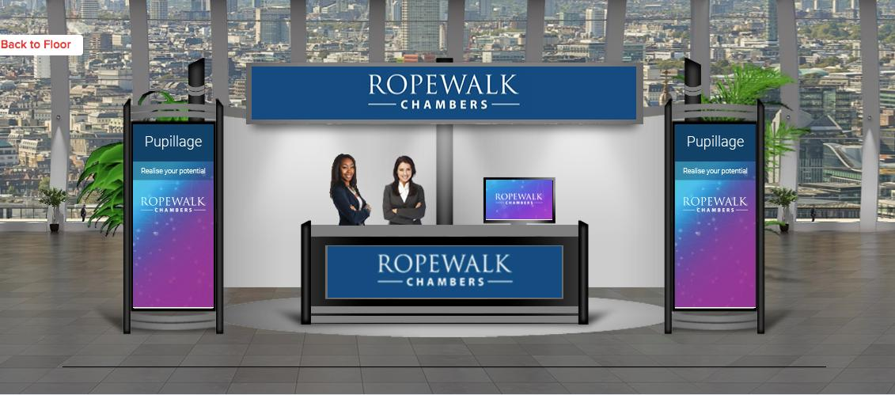
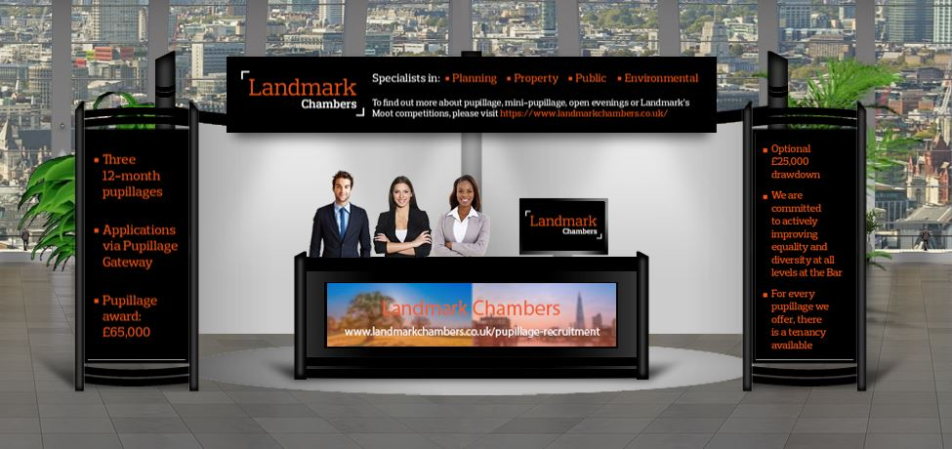

- An Auditorium capable of hosting pre-recorded and live webinars, the programme for which will be determined by the Bar Council and will include topics such as “Life at the Chancery and Commercial/Criminal/Family Law/Employed Bar”, “Career Changers”, “Applicants with Disabilities” and “Funding and Support from the Inns of Court”.

Figure 4: Auditorium – Pupillage Fair 2020
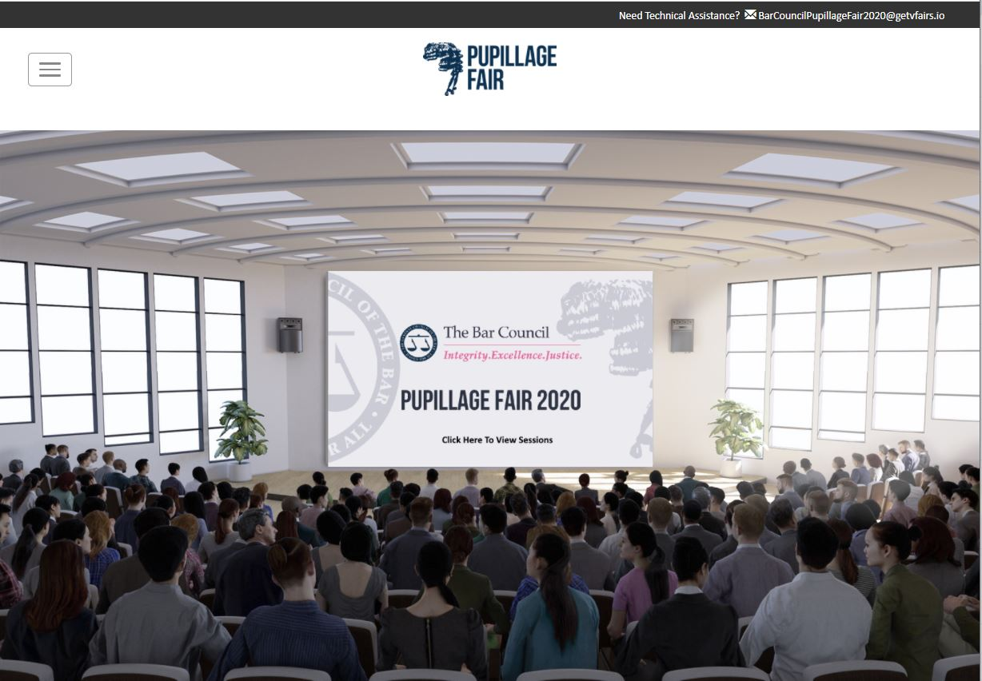

- A new CV Clinic Booth, through which aspiring barristers will be able to connect with volunteer barristers using video, audio and text chat functions, and share links to their CVs or pupillage applications.

- What upgrades have been made to the platform?

Since November 2020 and following feedback received from both aspiring barristers and exhibitors, the Bar Council’s Pupillage Fair Project Team has been working with vFairs to improve the platform. To that end and as a minimum, exhibitors can expect the following improvements at the Pupillage Fair 2021:
- Exhibitors will be able to select their own avatars as part of the booth creation process, improving the diversity of the event and ensuring that the Bar is seen as a profession that is welcoming to all.

- The use of smaller exhibition halls in which all relevant booths will be visible on a single screen, ensuring equality of opportunity amongst our exhibitors.

- Aspiring barristers will be able to search the platform based on certain preferences (for example, area of specialism), all of which will be determined by exhibitors’ answers to several relevant questions.

- Aspiring barristers will be given the ability to begin private conversations with exhibitors, empowering attendees and improving the potential for interaction.

- An optional moderated chat within each booth (see Figure 5 below), which will enable exhibitors to save time by managing a static feed containing the common questions posed by aspiring barristers, and the relevant answers.

- Exhibitors will be able to create and move between multiple private group chats within their booth and, if they choose to do so, share the links to them with attendees through both the attendee directory and the chat feed within their respective booths. This will enable exhibitors to have private text or video conversations with several aspiring barristers at once, and to have a private group chat that is set-up simply for their own representatives.

Figure 5 – Example of Moderated Chat Function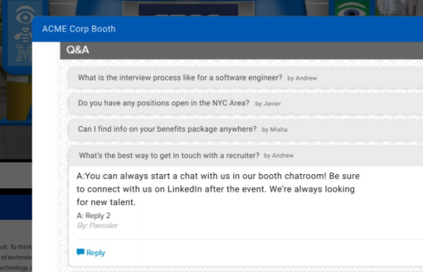

- How much does it cost to exhibit at the Pupillage Fair?

The Exhibitor price will be £670 plus VAT and will include the following benefits:

- The inclusion of your organisation on the Pupillage Fair 2021 page of the Bar Council’s website

- The inclusion of your organisation and logo in the electronic brochure for the Event.

- The inclusion of your organisation in the attendee directory, which will enable Exhibitor and Attendee ‘matching’ through a bespoke search engine devised by the Bar Council working in conjunction with vFairs.

- A virtual Booth at the Event, the design of which will be determined by you and which will enable you to provide aspiring barristers with:

  - Access to electronic documents, such as Pupillage Guides.
  - Access to videos and presentations created by you.
  - Access to a static moderated chat containing your answers to the most asked questions.
  - The opportunity to enter in to live 1:1 and group text, audio or video chat conversations with your representatives.

- You will also be able to use their Booths to create a private chat room in which their representatives can converse by text, audio or video.

- Post-event, you will also receive an anonymised aggregated report relating to the diversity of all attendees, and a bespoke aggregated report relating to the diversity of the attendees that visited your Booth.

Those who can pay the full price of £670 plus VAT should email the Bar Council’s Training and Events Team at trainingandevents@barcouncil.org.uk to reserve a booth and receive a copy of the Exhibitor Agreement for signature and return.

- We would like to exhibit but we cannot afford to. Does the Bar Council offer any discounts?

The Bar Council remains committed to offering pro bono and discounted booths to AETOs who:
- Receive grants from the Council of the Inns of Court Pupillage Matched Funding Scheme.

- Undertake a significant amount of publicly funded work.

- Are newly established as pupillage providers.

Furthermore, in recognition of the issues that the Bar is currently facing, we will also be offering pro bono and discounted booths those AETOs who witnessed their finances fall by over 60% during the pandemic, and who are yet to recover from the loss.
Those who fall into any of the categories outlined above are invited to email the Bar Council’s Training and Events Team at trainingandevents@barcouncil.org.uk and set out:
- Why you would like to participate in this year’s event, particularly if you have not joined a previous Bar Council Pupillage Fair.

- Your reasoning for requiring a pro bono or discounted Booth.

- The amount that you would reasonably be able to pay for a Booth.

Applications will be assessed on an ad-hoc basis and must be received before close of business on Friday 16 July 2021.

- Will the Pupillage Fair remain virtual from now on?
No. Like our main competitors, the Bar Council is holding the Pupillage Fair 2021 online owing to ongoing uncertainty around the potential impacts of Covid-19 later this year. Over the coming months our Project Team will be investigating the possibility of holding a hybrid event from October 2022 onwards and we hope to announce further details about the format of the Pupillage Fair 2022 towards the end of the year.

- I have got a question. Who can I contact?

The Bar Council is always happy to answer your questions. For further information about the Pupillage Fair please contact our Training and Events Team at trainingandevents@barcouncil.org.uk.

