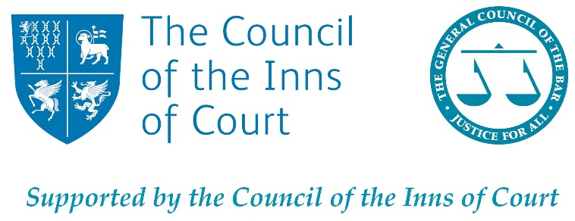

Bar Placement Scheme Application Form - Bristol
30 June-3 July 2020

Please note that the statements below must apply to you to apply to this scheme:
I am available to take part in the week – 30 June to 3 July 2020.
I am currently in Year 12 or 13, attending a state school or college.
I have a strong interest in the law and becoming a barrister.
I have read the ‘Becoming a Barrister’ brochure.

*This MUST be fully completed and submitted to BPS@BarCouncil.org.uk by Wednesday 8 May 2019 to be considered for a placement.
Name
Date of Birth
Gender
Address
Email
Mobile phone
Home phone
Current school
Medical or access requirements
Dietary requirements
Religious or cultural requirements
How did you hear about the scheme?

Emergency Contact 1
Name
Relationship to student
Address
Home phone
Mobile phone

Emergency Contact 2
Name
Relationship to student
Address
Home phone
Mobile phone

A/S Level Subjects
Subject | Predicted grades (if known)

GCSE Grades
Subject | Result

If you feel that you underwent extenuating circumstances during your exams, which may have affected your ability to achieve your predicted grades, please expand below.

Your preferred areas of law (in order of preference)

‘Please label the areas of law are you most interested in order of preference’ (e.g. Chancery/Commercial 1, Family 2, Crime 3)
Crime
Chancery/Commercial
Public law and human rights
Employment
Tort (e.g. personal injury, negligence)
Family (please note: most family law placements are for over-18s only)
Other – please specify

Please note that we cannot guarantee that you will get a placement with your preference.

Please do not use more than 200 words for each of 5 the questions below.

1. Why would you like to take part in the Bar Placement Week 2020?

2. What do you spend most of your time outside of school/ college doing?

3. What do you think is the biggest problem facing the world today, and how would you attempt to resolve it?

4. Are you a product of your environment? Please explain why you agree or disagree with this statement.

5. Discuss a recent court case or legal news story which you found interesting. You should think about facts and the outcome of the case. It could be of local, national or international importance. Please see here, here and here for inspiration.

Reference
If you are successful, we will need to contact your referee (who should be someone from your school e.g. your form tutor or head of year).
Name
Position at school
Phone number
Email address

Please email your application form and consent form (below) to BPS@BarCouncil.org.uk by Wednesday 22 April 2020.

Consent Form
For Parents, Carers or Guardians

This part of the form asks for some information on you, as well as for your consent for your child to take part in the Bar Placement Week 2020.

Please note: This section MUST be completed to be considered for a placement.

Parent/Guardian 1’s Name:  ....................................................................  Parent/Guardian 1’s Occupation:  .................................................................... | Parent/Guardian 2’s Name:  ....................................................................  Parent/Guardian 2’s Occupation:  ....................................................................
What is the highest level of qualification achieved by either parent/guardian?
Degree level or degree equivalent or above
Qualifications below degree level (e.g. A-levels, GCSEs or equivalent)
No qualifications
Don’t know
Prefer not to say

Has your child received free school meals since Year 7? | Yes No
Does your child have caring responsibilities?  If yes, please specify approximately how many hours per week. | Yes No  ……………………………

As Parent/Guardian of ________________________________, I give permission for them to take part in the ‘Week in the Life of a Barrister’ 30 June - 3 July 2020, should they be selected (including the Advocacy Training in London on Friday). I also give permission for them to be filmed or photographed for publicity purposes. The Bar Council would never use students’ full names in any publicity.
I also understand that, if successful, this form will be shared with the organisation where the placement is taking place. Please see here for our privacy statement: https://www.barcouncil.org.uk/privacy-statement/.

I certify that all the information above, to the best of my knowledge, is truthful.

Signed _______________________________ Print name ______________________________

Date _________________________________

