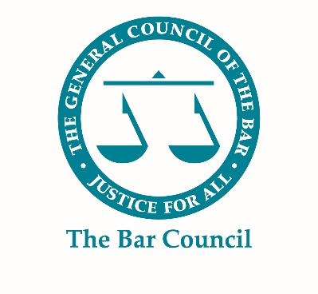
Third Six Vacancy

Chambers Information
Name of chambers | Joseph Hage Aaronson LLP
Address of chambers | 280 High Holborn  London WC1V 7EE
Chambers email | recruitment@jha.com
Chambers website address | https://uk.jha.com/

Vacancy Information
Number of third six pupillages | 2
Level of guaranteed earnings | Commensurate with newly qualified associate salary
Closing date | 28th September 2020
Pupillage start date | July 2020

Description and how to apply
Joseph Hage Aaronson LLP (www.jha.com) is a specialist litigation law firm acting in complex and high value disputes. Our firm is made up of leading barristers and solicitors from various dispute resolution specialisms and backgrounds including financial and commercial litigation, international arbitration and tax litigation.

We are interested in applications from pupils who are completing (or who have already completed) a pupillage at a leading chambers specialising in commercial litigation, arbitration or tax law. We invite applications from current pupils about to complete their pupillage for a position equivalent to a Third Six, with a view to being kept on in a permanent position as a barrister.

Applications should be made by email and include a CV and covering letter and should be sent to Human Resources by email (recruitment@jha.com). Applicants must mention in the subject of the email ‘Third Six Pupillage’.

Due to the high volume of CVs we receive, we unfortunately cannot commit to reply to each applicant. If selected for interview, the successful applicant will receive an email within 7 working days after sending the application.

Posted:

